Traffic Signal Identification for Blind people using Wireless Networks

***Abstrac******t:*** In this digitalized world, all our day-to-day routines are getting easier via technology. Wireless communication technology has become an integral part of our day-to-day life. But still visually challenged people face lot of difficulties in their daily life and depend on others for their daily needs. One of the challenges they face is walking in the road independently. Usually, blind people use a white cane which detect obstacles in a close range(manually), but it cannot detect the condition of traffic signal. So, we proposed a Smart wearable system using Wireless RF technology which reduces the risk and difficulties faced by the blind people in the pathway. This proposed system is an add-on of current traffic light system using Microcontroller, RF transceiver simulator and ultrasonic sensor which detects traffic signal and obstacles in real-time and guides the blind to cross the pathway independently and safely. The main aim of this system is to recognize the traffic signal pattern and obstacle detection and guides blind people to travel independently in unknown areas. Ultrasonic sensor which is used to detect obstacle from the user position consists of 3 major parts: A transmitter, a receiver and a timer. To measure a distance the timer triggers the transmitter which emits a series of pulses, and then the timer waits until the receiver detects the reflection of the pulses and stops the timer. Whenever the blind people start walking, then the ultrasonic sensor senses any obstacles and pit holes and provides indication to the microcontroller. Using RF transmission, traffic light information is passed to microcontroller. Then the Voice IC attached to the controller notify the blind people about the obstacle and the color of traffic signal to them using Earphone. This developed system is a low cost, user friendly aid which provide a safe walking environment for the visually impaired people.

Keywords—Wireless communication, RF Technology, Ultrasonic Sensor, Voice Assistance, Microcontroller.

*1.INTRODUCTION*

The wireless communication revolution is bringing fundamental changes to data networking, telecommunication, and is making integrated networks a reality. Wireless networks use radio waves to connect devices such as laptops to the

Internet, the business network and applications. When laptops are connected to Wi-Fi hot spots in public places, the connection is established to that business’s wireless network. There are four main types of wireless networks: Wireless Local Area Network (LAN which links two or more devices using a wireless distribution method, providing a connection through access points to the wider Internet, Wireless Metropolitan Area Networks (MAN) that connects several wireless LANs, Wireless Wide Area Network (WAN) that covers large areas such as neighbouring towns and cities and Wireless Personal Area Network (PAN) that interconnects devices in a short span, generally within a person’s reach.

World Health Organization gives statistics results that there are 285 million visually impaired people, out of which 39 million are totally blind. They are facing a lot of difficulties in their day to day life. About 90 per cent of visually impaired people are living in low income setting and so the guidance system should be designed in such a way that incurs low cost. One of the consequences of being visually impaired is being uncomfortable about safety while travelling independently as they are in unfamiliar environments. Many guidance systems are proposed in the Past to ease the mobility of visually impaired people. A variety of techniques are there which a blind person frequently uses such as white cane or walking stick for navigation. But there are many limitations with this such as the length of the cane as well. The blind people cannot cross the traffic signal on their own and depend on others to cross the road and traffic signal. In today’s world, independent walk is the main issue for the visually impaired peoples.

So, on taking this into account we decided to design a product which would help the blind people specifically to cross the road. The aim is to develop a portable, low cost and user friendly navigation system for the blind. This project involves helping the blind to recognize traffic signal pattern as well as obstacles around and to cross the road without depending on others. Usually, blind people use a first aid, such as the white cane. It allows them to detect obstacles in a close range, but cannot help them with detecting the condition of a traffic light. In this paper, we implemented a system that enables the blind to cross the pedestrian crossings independently. First, the current signal state is accurately recognized so that the visually impaired can know the state of the crosswalk. Ultrasonic sensors are used to detect the obstacles on the path as well. The visually impaired person can navigate faster and more safely among the obstacles by the use of these sensors. The system recognizes crosswalk lights in real time and detects obstacles and guides the current signal and objects detected to the visually impaired by voice and buzzer. This will provide a safe walking environment for the visually impaired.

# **SYSTEM ARCHITECTURE**

This system is proposed with three modules .It consists of object and depth detection, Voice IC and Traffic light. The Ultrasonic sensor is used to detect the obstacle in the area. Whenever the blind people start walking, then the ultrasonic sensor senses any obstacles and pitholes and provides indication to the microcontroller. Then the Voice IC attached to the controller signals the blind people about the obstacle and passes instructions to them using Earphone. Using RF transmission, traffic light information is passed to microcontroller to headphone.

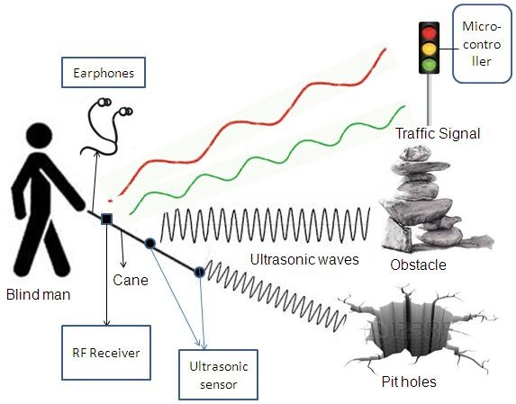

System architecture of Safe travel assurance for visually impaired using voice assistance.

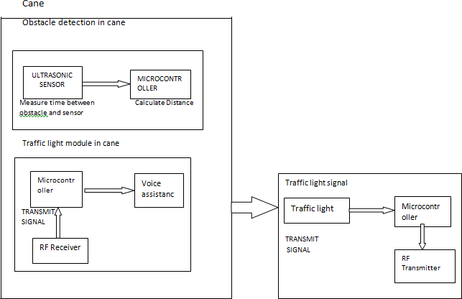

Functional architecture

## **Microcontroller**

The PIC microcontroller PIC16f877a is one of the most renowned microcontrollers in the industry. This controller is very convenient to use, the coding or programming of this controller is also easier. One of the main advantages is that it can be write-erase as many times as possible because it use FLASH memory technology. PIC16f877a finds its applications in a huge number of devices. It is used in remote sensors, security and safety devices.

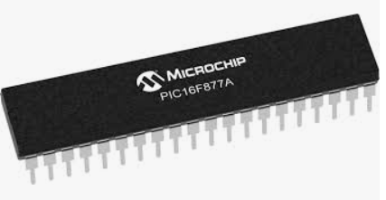

c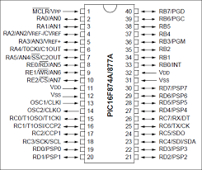

Microcontroller is connected to the ultrasonic sensors and voice IC. Using the ultrasonic sensors the distance of the obstacle from the blind is calculated. The voice IC which is connected to the microcontroller is used to give voice assistance to the blind using headsets regarding the obstacle and change in traffic lights.

## **Ultrasonic Sensors:**

An Ultrasonic sensor is a device that can measure the distance to an object by using sound waves. Ultrasonic transmitter emitted an ultrasonic wave in one direction and started timing when it launched. Ultrasonic waves spread in the air and would return immediately when it encountered obstacles on the way. At last the ultrasonic receiver would stop timing when it receives the reflected wave. The distance of sensor from the target object is calculated.

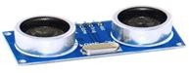

An RF transmitter module is capable of transmitting a radio wave and modulating that wave to carry data. Transmitter modules are usually implemented alongside a micro controller which will provide data to the module which can be transmitted. RF transmitters are usually subject to regulatory requirements which dictate the maximum allowable transmit power output, harmonics, and band edge requirements. An RF receiver module receives the modulated RF signal, and demodulates it. The receiver operates at 433.92MHz, and has a sensitivity of 3µV.

## **Voice IC:**

Voice assistance is provided for every activity carried out. Voice IC is connected to the microcontroller .During object and depth detection voice assistance is provided to the blind regarding the distance of the object and detection of the depth through headset. During traffic signal the blind is notified when the signal changes through voice assistance.

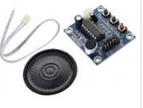

## **I**.**MODULE DESCRIPTION**

## **II**.**Object and Depth Detection:**

This module makes use of ultrasonic sensors and microcontroller. An Ultrasonic sensor is a device that can measure the distance to an object by using sound waves. It measures distance by sending out a sound wave at a specific frequency and listening for that sound wave to bounce back. By recording the elapsed time between the sound wave being generated and the sound wave bouncing back, it is possible to calculate the distance between the sensor and the object.

The similar technique is used for depth detection where a threshold is set. Any hollow surface above the threshold will be detected and the blind is notified using voice assistance.

Fig.4 - Flowchart of Object and depth detection

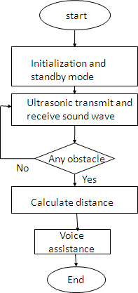 Module

Fig.5 - Flowchart of Traffic

Light Module

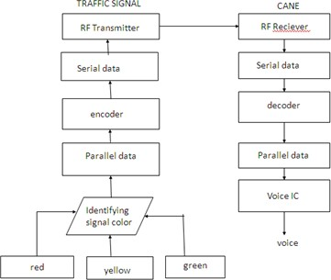

This module makes use of the RF Transmitting and Receiving technology. When the traffic signals change, the microcontroller inside the traffic signal will transmit to the microcontroller inside the cane using wireless RF technology. First, there is a transmitter which begins the RF communication. The transmitter takes the initial data and modifies the signal using a modulation technique to encode the data into the signal. Next, an antenna collects the signal that it receives from the transmitter and directs the RF waves away from the antenna. As the RF waves move away from the transmitting antenna they move towards another antenna attached to the receiver, which is the final component in the wireless medium. The receiver takes the signal that it received from the antenna and translates the modulated signals and passes them on to be processed. The Voice IC which is connected to the microcontroller inside the cane will send voice assistance to the blind through headset. This will help the blind to cross safely with respect to the signal.

**RESULTS AND DISCUSSION:**

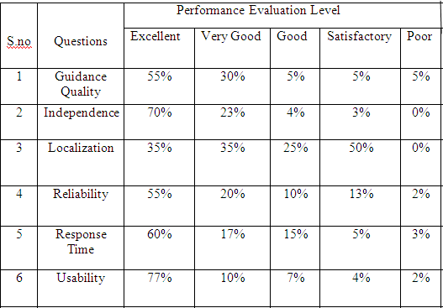

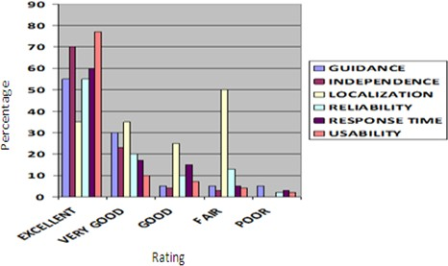

|  |  |  |  |  |
| --- | --- | --- | --- | --- |
| S.NO | Range (cm) | Calculation (Mv)3 cm=10  Mv | Meaured (Mv) | Error |
| 1 | 0 | 0 | 0 | 0 |
| 2 | 5 | 50 | 45 | 0.1 |
| 3 | 10 | 100 | 97 | 0.03 |
| 4 | 15 | 150 | 142 | 0.05 |
| 5 | 20 | 200 | 193 | 0.035 |
| 6 | 25 | 250 | 245 | 0.02 |
| 7 | 30 | 300 | 29 | 0.01 |
| 8 | 35 | 350 | 340 | 0.02 |

## **A.CONCLUSION AND FUTURE WORK**

The basic aim of this paper was to develop and implement obstacle detection system for visually impaired people with the help of ultrasonic sensors. This paper also proposes a design to help the blind to recognize traffic signal pattern. An audio output about the distance at which the obstacle is present and information about the traffic signal, is proved to be highly efficient.

For a more practical use a more advanced microcontroller is recommended that minimizes the size and is easily portable. Radio technology requires the presence of electricity, both at the point of the transmission and the point of reception. The power needs for this are heavy and requires frequent charging. Future work should concentrate on including GPS to make the cane smarter and useful for the visually impaired to guide them to their desired destination. Changes in nature, for example, temperature, weight, mugginess, air turbulence and airborne particles influence ultrasonic reaction. Since the ultrasonic sensors are very sensitive to temperature variation and has more difficulties in reading reflections from soft, curved, thin and small objects, these aspects can be corrected in future work.

***References***

1. Jayant Sakhardande, Pratik Pattanayak, MitaBhowmick **“Smart Cane Assisted Mobility for the Visually Impaired”** World Academy of Science, Engineering and Technology International Journal of Electrical and Computer Engineering, 2012.
2. A. Aladrén, G. López-Nicolás, Luis Puig, and Josechu J. Guerrero” **Assistance for theVisually Impaired Using RGB-D Sensor With Range Expansion”** IEEE SYSTEMS JOURNAL 2014.
3. R. Mohanapriya, U. Nirmala, C. Pearlin Priscilla **“Smart vision for the blind people”** International Journal of Advanced Research in Electronics and Communication Engineering (IJARECE) July 2016.
4. Mun-Cheon Kang, Sung-Ho Chae, Jee-Young Sun, Sung- Ho Lee, and Sung-JeaKo, Fellow, **“An Enhanced Obstacle Avoidance Method for the Visually Impaired using Deformable Grid”** IEEE Transactions on Consumer Electronics,May 2017.
5. Hsinfu Huang, Tai-Chun Lin, Dengchuan Cai **“Non- visual traffic signal information: An investigation of the recognition performance of blind users using the wearable tactile traffic lights assist device”** International Journal of Industrial Ergonomics 57 (2017).
6. Van-Nam Hoang,Huong Nguyen ,Thi-Lan Le ,Thanh-Hai Tran ,Tan-PhuVuong ,Nicolas Vuillerme**“Obstacle detection and warning system for visually impaired people based on electrode matrix and mobile Kinect”** Vietnam J ComputSci (2017).